# MarketForce Interactive Graphic Handoff

## Styles

### Internal Styles

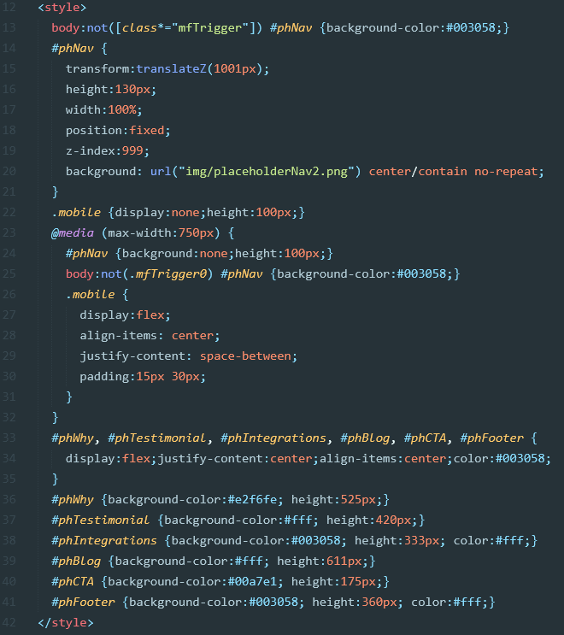Internal styles found in the <head> of *index.html* are strictly for the presentation of placeholder content. Lewis should not need any of these styles. With that said, it might be helpful for Lewis to reference some of these styles when they develop their elements that are affected by the interactive graphic section, like the sicky navigation.

### External Styles

The only external stylesheet required is *styles.min.css*. The .zip file provided by MarketForce also includes the original *styles.scss* file and prettified *styles.css* file so Lewis can implement/edit the styles any way they like.

## HTML

### Required Markup

Required markup includes everything within the “Start/End MarketForce Section” comment tags.

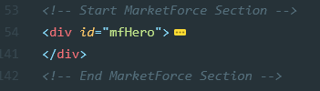Also (not required, but…) highly recommended is adding the class “mfTrigger0” to the body. This sets the initial styles for the interactive graphic.

### Placeholder Markup

All other markup in *index.html* is placeholder content used for presentation purposes only.

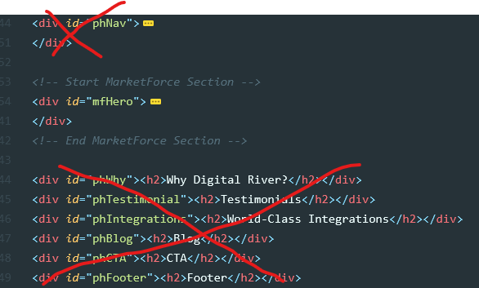

## Scripts

The only required script is *scripts.min.js*. This file can be placed anywhere **after** jQuery. The .zip file provided by MarketForce also includes the original *scripts.js* file so Lewis can implement/edit the scripts any way they like. The script files includes the [ScrollMagic plugin](https://github.com/janpaepke/ScrollMagic).

